STATION #1:
Geometric Properties

1. Find the values of x and y in the picture.
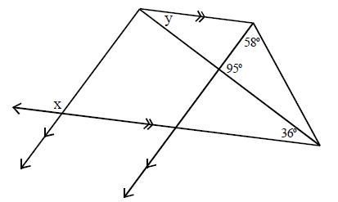

2. Find the values of q, r, and s in the picture.
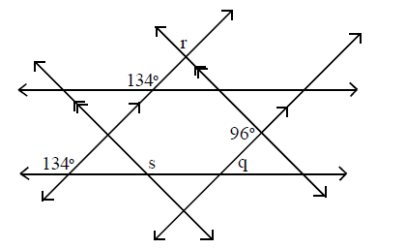

3. Draw and label a picture to represent the following:
- Line WZ includes points X and Y so that X is the midpoint of segment WY and Y is the midpoint of XZ.
- Angles WXA and BXY are obtuse vertical angles.
- Angles AXY and YXC are complementary.
- BXC is a right angle.
STATION #2:
Triangle Congruence

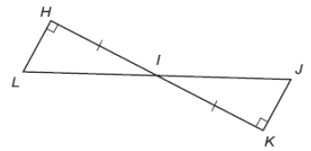
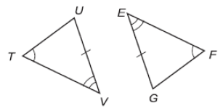
Determine whether each pair of triangles is congruent. If so, write a congruence statement and explain why the triangles are congruent. If it is not possible, write not possible.

1.
2.
3.

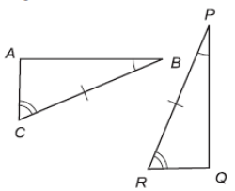
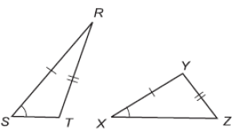
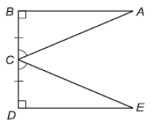

4.
5.
6.

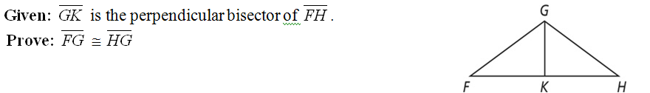
Write a two column proof.
4.

STATION #3:
Parallelograms

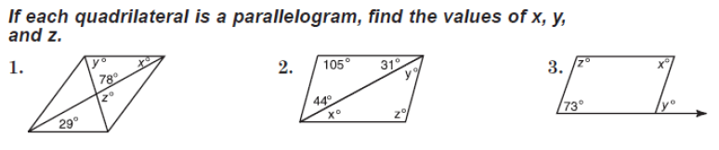

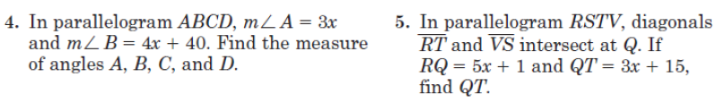

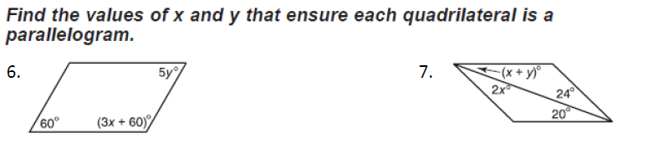

STATION #4:
Similar Polygons
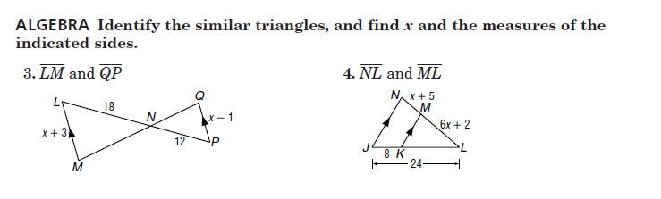

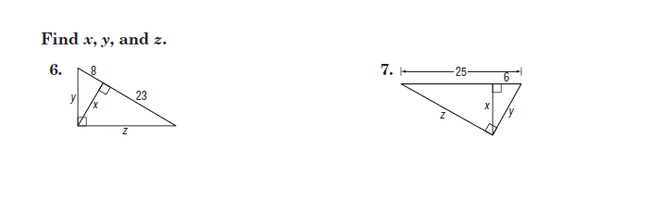

STATION #5:
Parallel Lines and Transversals

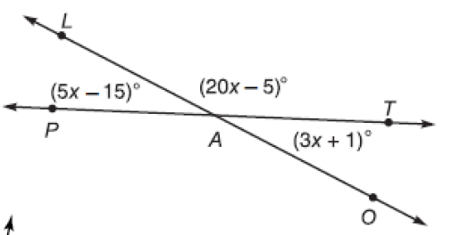
- Use the figure to find:
  - x =
  - m$∡$LAT
  - m$∡$TAO
  - m$∡PAO$

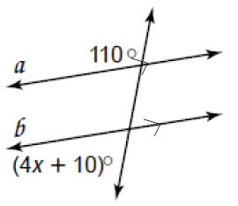
- Find x.

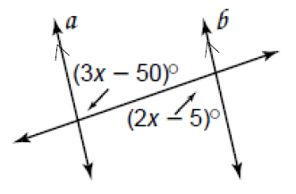
- Find x.

STATION #6:
Proofs

- 