AFM – Unit 2 EXTRA REVIEW: Graphing Trig
Part 1: Given the equation find the amplitude, period, vertical shift and phase shift.
1) $y=2\sin{4(x-\frac{3π}{4})}+3$ Amplitude: ______
Period: ______ Phase Shift: _________ Vertical Shift _________

Part 2: Given the graph find the amplitude, period, vertical shift and phase shift. Then write the equation.
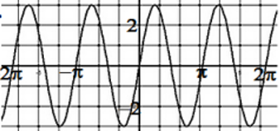
2. Amplitude ____________ Phase shift ____________

Vertical shift ___________ Period ____________

Sine Equation ____________________

3. The table shows the height of a spring in cm after x seconds.
seconds | 0 | 2 | 5 | 8 | 10 | 12 | 15 | 16 | 18 | 20 | 21 | 23
Height | 1.0 | 3.2 | 6.2 | 10.4 | 9.5 | 6.8 | 3.4 | 1.2 | 3.6 | 6.5 | 8.4 | 10.0

- Find a sine equation for that gives height as a function of time. ______________________

- What is the period for this function? _____________________________________

- Use your equation to predict what the height will be in 1 minute. ______________

- What is the average height of the spring? _________________

- What is the max and min height of the spring?_______________________________

4. The zebra on the carousel has a minimum height of 3 feet at 2 minutes and 6 feet at 5 minutes. Find:

Amplitude - ________ Vert. Shift- ___________ Period - ____________ Phase Shift - _______
Equation: _______________________________

