Math 3 ~ Unit 1: Functions & Their Inverses Test Review!

**Section #1: Find the appropriate solution for the assigned function(s)**

**f(x) = 3x – 8 and g(x) = -2x2 + 5x – 7**

1. **f(0) 2. f(g(2)) 3. 2[f(2) – g(1)]**
2. **f(g(x)) 5. f(x) – g(x) 6. f(2z) + g(z)**

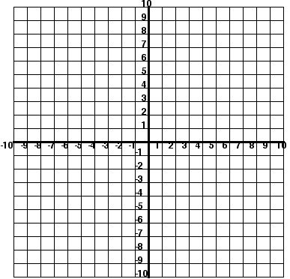**Section #2: Find the solution(s) to the following system.**

1.  **Solutions:______________**

**Section #3 Sketch the solution for each inequality.**

|  |  |
| --- | --- |
| http://mste.illinois.edu/courses/mat764fa03/folders/jleel/Quadratic_Unit/grapha.jpg | http://mste.illinois.edu/courses/mat764fa03/folders/jleel/Quadratic_Unit/grapha.jpg |

**Section #4: Solve the systems of linear equations through graphing, substitution, or elimination. Use method indicted if possible.**

**10.** The equations  and  represents the amount of money collected from the Stone Creek Movie Theater. If “y” represents the cost of an adult ticket to get into the movie and “x” represents the cost of a child ticket to get into a movie then what is the cost of each adult ticket? Use any method! ☺

**METHOD 1: GRAPHING**

|  |  |
| --- | --- |
| **11.**  http://mste.illinois.edu/courses/mat764fa03/folders/jleel/Quadratic_Unit/grapha.jpg | **12.**  http://mste.illinois.edu/courses/mat764fa03/folders/jleel/Quadratic_Unit/grapha.jpg |

**METHOD 2: Elimination**

|  |  |
| --- | --- |
| **13.** | **14.** |

**Method 3: Substitution**

|  |  |
| --- | --- |
| **15.** | **16. $m+n=7$ $-5m+9n=21$** |

**Section #5: Evaluate each piece-wise function for its given domain.**

|  |  |
| --- | --- |
| **17.** | **18.** |

**19. Looking at #24 find: **

**Section #6: For each equation state the domain and range (using interval notation) then find the inverse and state the domain and range of the inverse. Also, determine if the inverse is a function.**

|  |  |
| --- | --- |
| **20.**  Domain:____________ Range:___________  f-1(x) = _____________________  Domain of f-1(x):___________  Range of f-1(x): ___________ | **21.**  Domain:____________ Range:___________  f-1(x) = _____________________  Domain of f-1(x):___________  Range of f-1(x): ___________ |
| **22.**  Domain:____________ Range:___________  f-1(x) = _____________________  Domain of f-1(x):___________  Range of f-1(x): ___________ | **23.**  Domain:____________ Range:___________  f-1(x) = _____________________  Domain of f-1(x):___________  Range of f-1(x): ___________ |

**Section #7 Absolute Value Equations & Functions**

|  |  |
| --- | --- |
| **24.** Solve each of the following. | **25.** Graph the following equation. Then describe the translate of g(x) = |x| to f(x).    http://mste.illinois.edu/courses/mat764fa03/folders/jleel/Quadratic_Unit/grapha.jpg |