AFM Unit 1 Review Name _________________________

Write an equation for the piecewise function.

- $g\left(x\right)=\left\{\begin{aligned} \\ \\ \end{aligned}\right.$

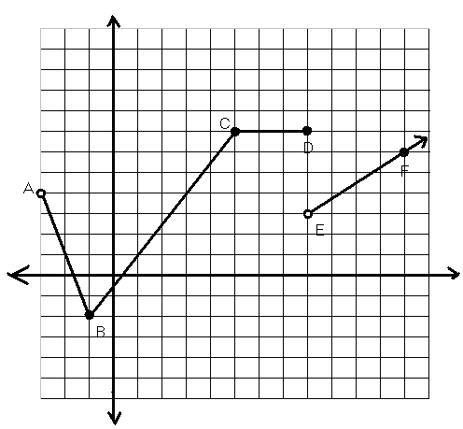
2). For the following function g, decide if each of the statements is correct. If it is incorrect, fix the equation or restriction to make it true.

Check one: |  | Statement | Correction to the Statement (if false)
True | False
 |  | From A to B, the restriction is -2< x < 4.
 |  | From B to C, the equation is g(x) =$\frac{3}{2}x-\frac{1}{2}$
 |  | From C to D, the equation is g(x) = 7.
 |  | To the right of E, the equation is g(x) = $-\frac{3}{4}x+3$
 |  | To the right of E, the restriction is x > 8.

Use the given function to evaluate each expression.
3. a. f (-1) = ________________
b. f (5) = _________________

4. For the function $f\left(x\right)={-(x+4)}^{3}$ find the following:
a) Translations : __________________________ b) Saddle Point: _______
c) Domain: ____________ d) Range: ________________________
e) Inc. Interval ___________________ f) Dec Interval: ________________________

5. $f\left(x\right)={(x-1)}^{2}+1$
a) Translations : __________________________ b) Vertex: _______
c) Domain: ____________ d) Range: ________________________
e) Inc. Interval ___________________ f) Dec Interval: ________________________

6. For the function $y=\log\left(x-1\right)-3$ find the following:
a) Translations : __________________________ b) Asymptote: _______
c) Domain: ____________ d) Range: ________________________
e) Inc. Interval ___________________ f) Dec Interval: ________________________

