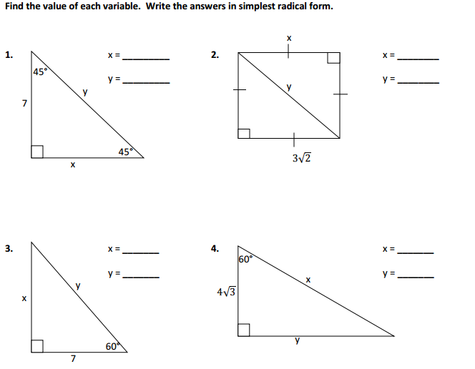
Unit 7 Quiz 1 Review Name:

Find the missing variable for the following. Round to the nearest tenth.
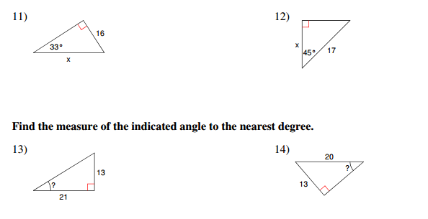

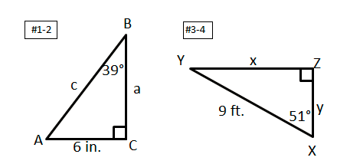
Solve the following triangles. Round sides to the nearest tenth and angles to the nearest degree.

Given the trig ratio, find the exact value of the remaining trigonometric ratios.
- $\sin{θ=\frac{2}{5}}$ | - $\cos{θ}$ | - $\tan{θ}$
- $\sec{θ}$ | - $\cot{θ}$ | - $\csc{θ}$

